Remote Computer Review Instructions and Guidance

Due to COVID-19, social distancing measures will be observed. As a result, a review of all computers used for XXX Business (Home and Office computers) will be remotely conducted using Cisco Webex. Please note, the remote review will follow the same protocol as in-person. This document will provide instructions on how to use your smartphone for video conferencing and how to use WebEx for the remote computer inspection.

Helpful Tips
- Inform all advisors and staff of this requirement.
- Prior to the remote branch exam, make sure all computers used for XXX Business are able to access Webex.
- A few minutes before the scheduled appointment, open the Webex invite and click Join Meeting.
- Each remote computer review should take approximately twenty minutes.

Smartphone – Used for Video-Conference
Download Webex Meeting App for iPhone
Download Webex Meeting App for Android

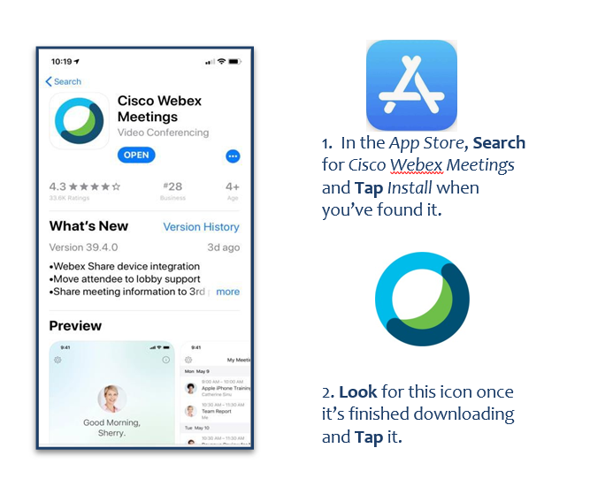
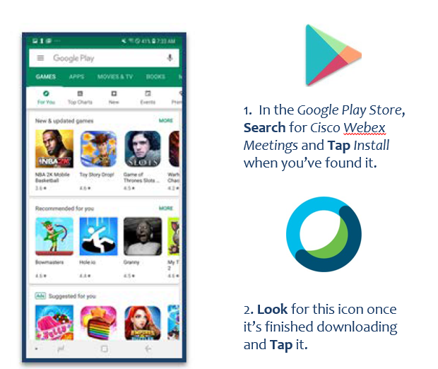

Computer – Used for Remote Computer Review

Download Webex Meetings: https://www.webex.com/content/webex/c/en_US/index/downloads.html
Video on How to Join a Webex meeting: https://help.webex.com/en-us/nrbgeodb/Join-a-Webex-Meeting

Get Started with Cisco Webex Meetings for Attendees

Webex Meetings makes joining and collaborating hassle free. You can meet anyone in the he world online, talk to them over the phone or your computer, see each other's video and share content.

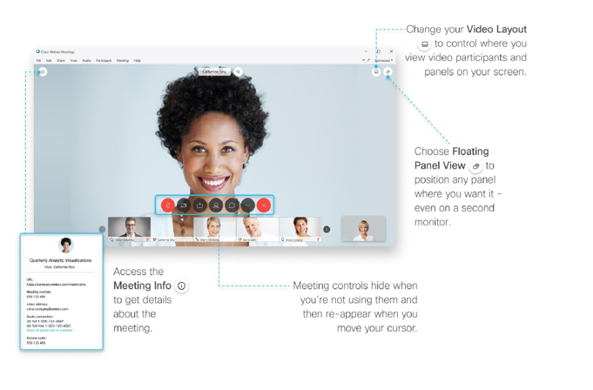
Join a Meeting
If someone invites you to a Webex meeting, you receive an invite with instructions on how to join in an email invitation.
You can click the Join link to the meeting.
- You might be asked to enter a meeting password, it is in your email invitation.
The Webex user interface is simple. Meeting options in the center and participants and other panels on the right.

- Open your email invite, and click Join.
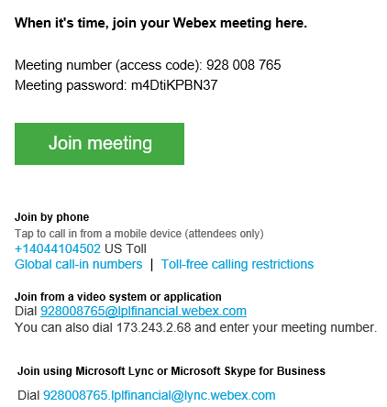

- If this is the first time you're joining a Webex meeting, Webex automatically downloads the app. Click the installer file to install the app.

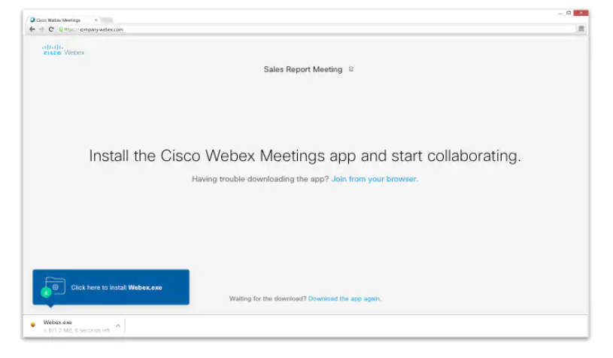

- Enter your name and email address, and click Next.
- If you're asked for a meeting password, enter the meeting password - it's in your email invitation - and click Next.
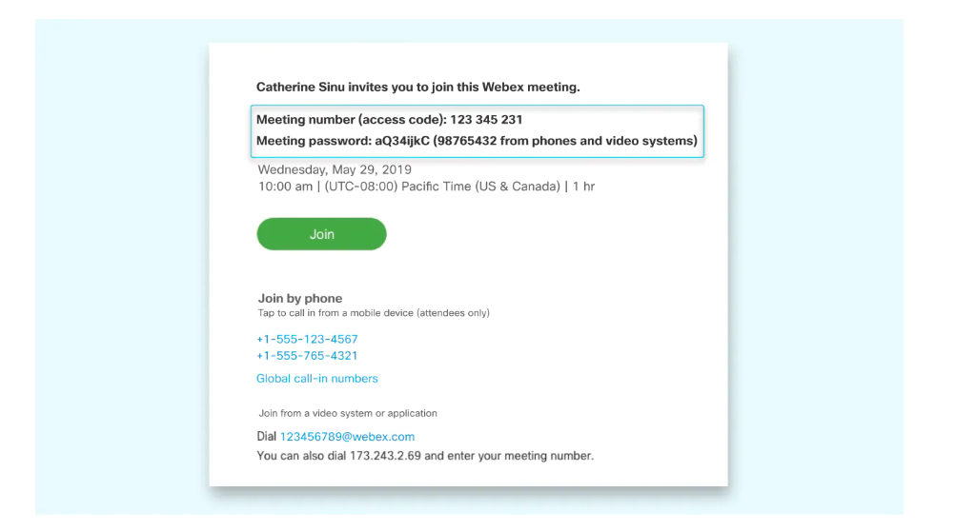

Connect Audio/Video
Before you join a meeting you can choose the settings you use for audio in the meeting.
- Click the audio connection options in the Webex Meetings app.

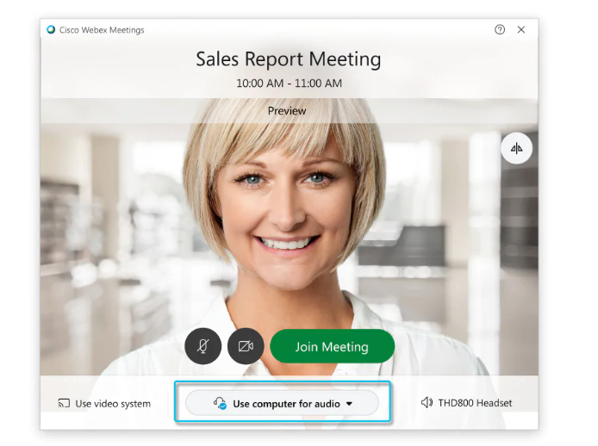

- Choose how you want to hear the audio in the meeting.
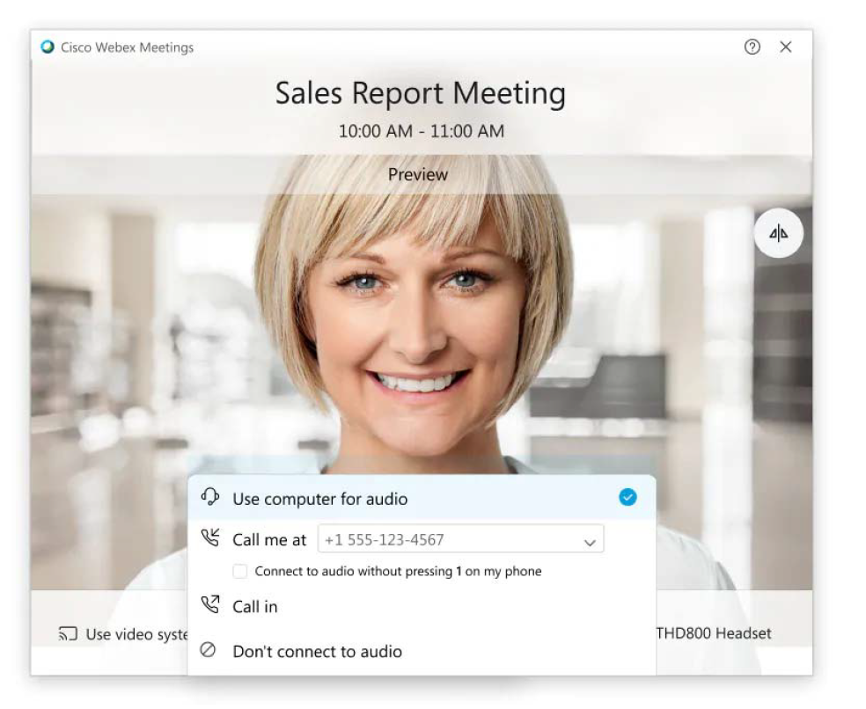

  - Use computer for audio-Use your computer with a headset or speakers.
This is the default audio connection type.
  - You can change your headset, speakers, and microphone.
  - Call me-Enter or select the work or home phone number that you'd like the meeting to call.
  - Call in-Dial in from your phone when the meeting starts. A list of global call-in numbers is available after you join the meeting.
  - Don't connect audio-You won't hear any audio in the meeting through your computer or phone. Use this option if you're in the meeting room but want to use your computer to share content in the meeting.

- By default, your microphone and camera are turned off. The video and microphone buttons are both red.
  - To join with your video on, click Start video.
  - To join with your microphone on, click Unmute.

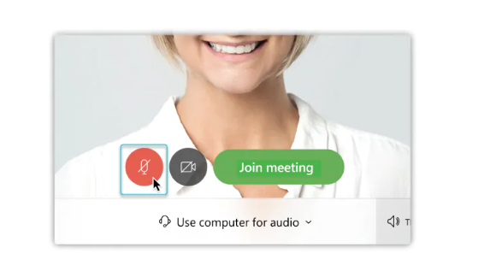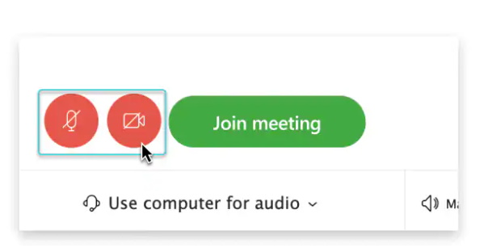

- Click Join Meeting.

Share Content
You can share content during a Webex meeting.
- Under the menu, click the Share button and select Share Content.
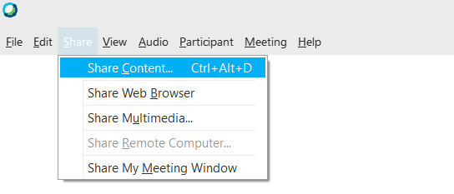
- Select the content to share.

- If using TWO monitors, select the PRIMARY monitor by clicking on Screen 1.

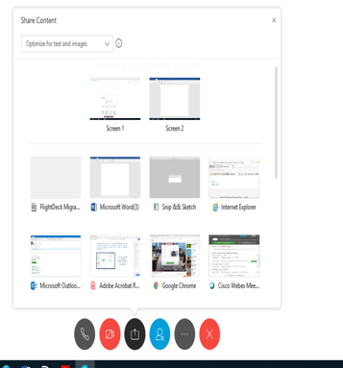

Remotely Control Shared Desktop
- During a Screen or Application share, move your mouse to the top of the screen, then click the Assign button.
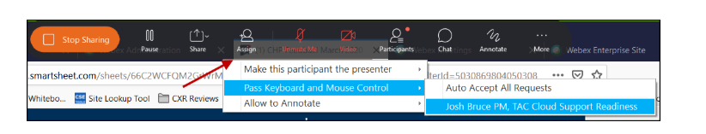
- Select Pass Keyboard and Mouse Control, then select the participant you would like to assign control to.
The participant will receive a message on their screen advising them to click on the screen to gain control.

macOS and Cisco Webex Meeting app
Mac OS versions no longer supported:

- 10.08
- 10.09
- 10.10
- 10.11
- 10.12

To view other participants' video and turn on your own video at the same time, recommend to use:

- Chrome, Firefox, Safari, or Edge browser.
- Switch to the desktop app.

Installing Webex Desktop App for macOS

The Webex Meetings desktop app automatically downloads after starting or joining a Webex meeting from a Webex site or email invitation.

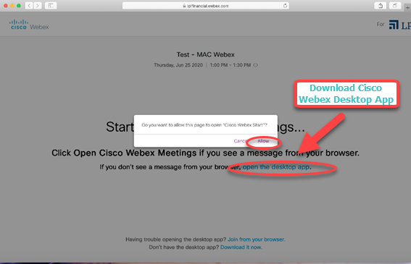

Connect Audio/Video
To allow video and audio, ensure that Cisco Webex Meetings is granted access to the permission.
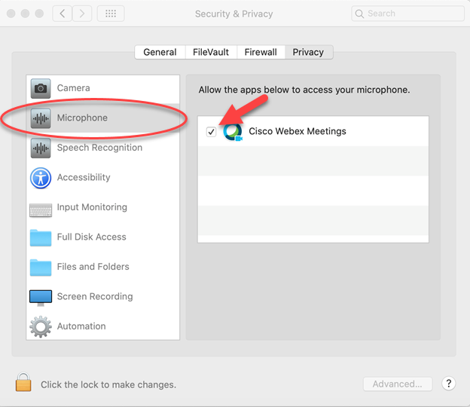
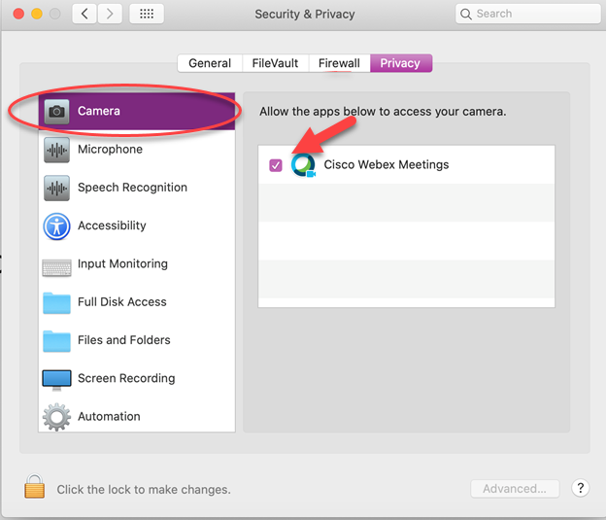

Share Applications and Remotely Control
Apple introduced new Security & Privacy features for masOS devices. With macOS Catalina 10.15, in order to share screen and assign control in the Webex Meetings desktop app, ensure Cisco Webex Meetings is granted access in Security & Privacy to the Screen Recording and Accessibility permission.
For more information about screen recording, see article Cisco Webex Web App Known Issues and Limitations: https://help.webex.com/en-us/n0rqd8g/Cisco-Webex-Web-App-Known-Issues-and-Limitations
