About this Application
This is a Retail Brokerage Account Application. Please read it carefully, as you will select products and services, tell us how you want to communicate with us, and agree to certain provisions that will govern our relationship. When we accept it, this Application and all accompanying or supplemental documents form the entire Agreement between us for this account.
Unless otherwise indicated in this Application, the words “you,” “your,” “yourself,” and “yours” mean the applicant(s). The words “we,” “us,” and “our” mean {Brokerage ABZ, 153 Securities Way, Suite 1001, Richmond, VA 00150} and our branches, subsidiaries, and affiliates.
Getting Started
Please complete and sign this Application, along with any required supplemental forms identified through this application process.
In order to complete this Application, you will need some or all of the following information:
- Identification information, such as a driver’s license, passport, or another type of government-issued identification
- Social Security Number
- Federal tax information
- Information about your annual income, debt, expenses, and net worth
- Trusted contact person information
- [Firms can include other relevant documents or information]
The above information helps us comply with various securities regulations and rules and the USA PATRIOT Act, a Federal Law that requires all securities firms to obtain, verify, and record information that identifies each applicant. Please note: if we cannot verify the information you provide, we may be required to restrict or deny your account.
Please remember to notify us if you experience a significant life change, such as the birth of a child, marriage, divorce, death of a spouse, loss of a job, change in financial situation, etc.


□ Individual Account
□ Joint Account (more than one account holder)
[Firms should include the appropriate joint account types consistent with the states in which they are doing business, e.g. Tenants by the Entirety, Joint Tenants with Right of Survivorship, Community Property, Tenants in Common, etc.]
Other Accounts
Do you have other accounts with us? □ Yes □ No

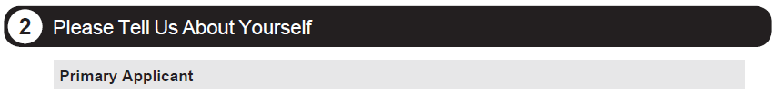
Contact Information
□ Mr. □ Mrs. □ Ms. □ Dr. Suffix □ Sr. □ Jr.
First Name Middle Name Last Name
Permanent Address Apt/Suite No.
City State ZIP Code Country
Work Phone Home Phone Mobile Phone Email Address
□ Please check if you have been at your current home address for less than one year.
Mailing Address (if different from above) Apt/Suite No.
City State ZIP Code Country
Are you:
□ Single □ Married □ Domestic Partner □ Divorced □ Widowed Number of Dependents:
Employment Status
Are you currently:
□ Employed □ Self-Employed □ Not Employed □ Retired □ Student □ Other:
Job Title Occupation
Employer Years with this Employer
Business Address Apt/Suite No.
City State ZIP Code Country
USA PATRIOT Act Information (Required by Federal law—See page 1)
All applicants please provide the information below. Non-resident aliens, also include a completed W-8BEN.
Date of Birth (mm/dd/yyyy) Social Security or Taxpayer ID No. Country of Citizenship
ID No. (Select one): □ Driver’s License □ Passport □ State ID □ Other Government-issued ID Place/Country of Issuance
Issue Date (mm/yyyy) Expiration Date (mm/yyyy) Country of Tax Residence (if different than country of citizenship)
Contact Information
□ Mr. □ Mrs. □ Ms. □ Dr. Suffix □ Sr. □ Jr.
First Name Middle Name Last Name
□ Use the same contact information listed for the primary applicant.
Permanent Address Apt/Suite No.
City State ZIP Code Country
Work Phone Home Phone Mobile Phone Email Address
□ Please check if you have been at your current home address for less than one year.
Mailing Address (if different from above) Apt/Suite No.
City State ZIP Code Country
Are you:
□ Single □ Married □ Domestic Partner □ Divorced □ Widowed Number of Dependents:
Employment Status
Are you currently:
□ Employed □ Self-Employed □ Not Employed □ Retired □ Student □ Other:
Job Title Occupation
Employer Years with this Employer
Business Address Apt/Suite No.
City State ZIP Code Country
USA PATRIOT Act Information (Required by Federal law—See page 1)
All applicants please provide the information below. Non-resident aliens, also include a completed W-8BEN.
Date of Birth (mm/dd/yyyy) Social Security or Taxpayer ID No. Country of Citizenship
ID No. (Select one): □ Driver’s License □ Passport □ State ID □ Other Government-issued ID Place/Country of Issuance
Issue Date (mm/yyyy) Expiration Date (mm/yyyy) Country of Tax Residence (if different than country of citizenship)
Trusted Contact Person Information (optional)
This voluntary template reflects FINRA Rule 2165 (Financial Exploitation of Specified Adults) and amendments to FINRA Rule 4512 (Customer Account Information) relating to financial exploitation of seniors. Please note that Rule 2165 and the amendments to Rule 4512 went into effect on February 5, 2018.

By choosing to provide information about a trusted contact person, you authorize us to contact the trusted contact person listed below and disclose information about your account to that person in the following circumstances: to address possible financial exploitation, to confirm the specifics of your current contact information, health status, or the identity of any legal guardian, executor, trustee or holder of a power of attorney, or as otherwise permitted by FINRA Rule 2165 (Financial Exploitation of Specified Adults).

Mr. Mrs. Ms. Dr. Suffix Sr. Jr.
First Name |  |  |  |  |  | Middle Name |  |  | Last Name
Address |  |  |  |  |  |  |  |  |  |  |  | Apt/Suite No.
City |  |  |  | State |  | ZIP Code |  |  |  | Country
Work Phone |  | Home Phone |  |  |  | Mobile Phone |  |  |  | Email Address
Relationship to Primary Applicant/Co-Applicant:
Industry and Other Affiliations
Primary Applicant | Co-Applicant | Are you, your spouse, or any other immediate family members, including parents, in-laws, siblings and dependents:
□ Yes □ No | □ Yes □ No | Employed by or associated with the securities industry (for example, a sole proprietor, partner, officer, director, or branch manager, registered representative or other associated person of a broker-dealer firm) or a financial services regulatory agency?  If yes, please specify entity below. If this entity requires its approval for you to open this account, please provide a copy of the required authorization letter (with this Application).  □ Broker-Dealer or Municipal Securities Dealer □ Investment Adviser  □ FINRA or other Self Regulatory Organization* □ State or Federal Securities Regulator  (*Including a national securities exchange, registered securities association, registered clearing agency or the Municipal Securities Rulemaking Board.)  Name of entity(ies):
□ Yes □ No | □ Yes □ No | An officer, director or 10% (or more) shareholder in a publicly-owned company?  Name of company and symbol:
□ Yes □ No | □ Yes □ No | A senior military, governmental or political official in a non-US country?  Name of country:  [Firms may consider whether to include this question in the context of their risk assessment procedures and the products and services they offer.]
Household Financial Background
Please tell us your best estimate as to:
ANNUAL INCOME¹  (from all sources) | NET WORTH²  (excluding your residence) | TAX RATE  (highest marginal)
□ $25,000 and under | □ $25,000 and under | □ 0-15%
□ $25,001-50,000 | □ $25,001-50,000 | □ 16-25%
□ $50,001-100,000 | □ $50,001-200,000 | □ 26-30%
□ $100,001-250,000 | □ $200,001-500,000 | □ 31-35%
□ $250,001-500,000 | □ $500,001-1,000,000 | □ Over 35%
□ Over $500,000 | □ $1,000,001-3,000,000
 | □ Over $3,000,000
¹ Annual income includes income from sources such as employment, alimony, social security, investment income, etc.
² Net worth is the value of your assets minus your liabilities. For purposes of this application, assets include stocks, bonds, mutual funds, other securities, bank accounts, and other personal property. Do not include your primary residence among your assets. For liabilities, include any outstanding loans, credit card balances, taxes, etc. Do not include your mortgage.
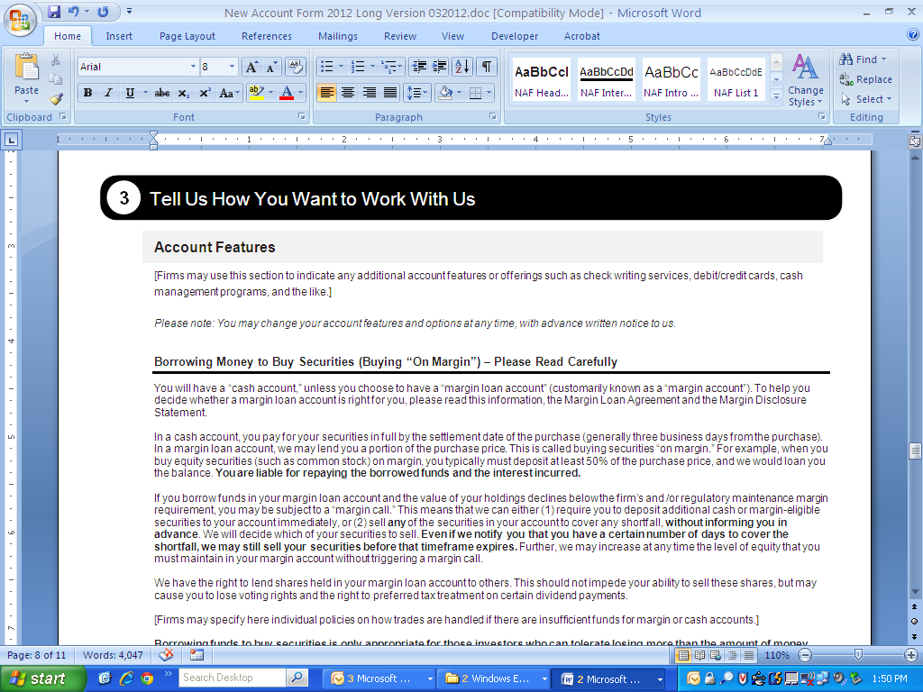
[Firms may use this section to indicate any additional account features or offerings such as check writing services, debit/credit cards, cash management programs, and the like.]
Please note: You may change your account features and options at any time, with advance written notice to us.
Borrowing Money to Buy Securities (Buying “On Margin”) – Please Read Carefully
You will have a “cash account,” unless you choose to have a “margin loan account” (customarily known as a “margin account”). To help you decide whether a margin loan account is right for you, please read this information, the Margin Loan Agreement and the Margin Disclosure Statement.
In a cash account, you pay for your securities in full by the settlement date of the purchase (generally three business days from the purchase). In a margin loan account, we may lend you a portion of the purchase price. This is called buying securities “on margin.” For example, when you buy equity securities (such as common stock) on margin, you typically must deposit at least 50% of the purchase price, and we would loan you the balance. You are liable for repaying the borrowed funds and the interest incurred.
If you borrow funds in your margin loan account and the value of your holdings declines below the firm’s and/or regulatory maintenance margin requirement, you may be subject to a “margin call.” This means that we can either (1) require you to deposit additional cash or margin-eligible securities to your account immediately, or (2) sell any of the securities in your account to cover any shortfall, without informing you in advance. We will decide which of your securities to sell. Even if we notify you that you have a certain number of days to cover the shortfall, we may still sell your securities before that timeframe expires. Further, we may increase at any time the level of equity that you must maintain in your margin account without triggering a margin call.
We have the right to lend shares held in your margin loan account to others. This should not impede your ability to sell these shares, but may cause you to lose voting rights and the right to preferred tax treatment on certain dividend payments.
[Firms may specify here individual policies on how trades are handled if there are insufficient funds for margin or cash accounts.]
Borrowing funds to buy securities is only appropriate for those investors who can tolerate losing more than the amount of money deposited in the account. To avoid the use of margin, even in a margin loan account, always pay for your purchases in full by the settlement date of the purchase.
- No I do not want the ability to borrow funds in my account, which means I will have a cash account.
- Yes I want the ability to borrow funds in my account. I have read the Margin Loan Agreement and the Margin Disclosure Statement and understand my rights and obligations under them.
Note: If you do not check any box above, by default you will have a cash account.
[Firms should indicate what type of account will be the default if the customer fails to indicate a choice above.]

Authorization to Trade (if applicable)
Please provide us with the contact information for any person other than the account holder(s) who has trading authorization over the account.
Mr. Mrs. Ms. Dr. Suffix Sr. Jr.
First Name |  |  |  |  |  | Middle Name |  |  |  |  |  | Last Name
Permanent Address |  |  |  |  |  |  |  |  |  |  |  |  |  | Apt/Suite No.
City |  |  |  | State |  |  |  | ZIP Code |  |  | Country
Work Phone |  | Home Phone |  |  |  |  |  | Mobile Phone |  |  | Email Address
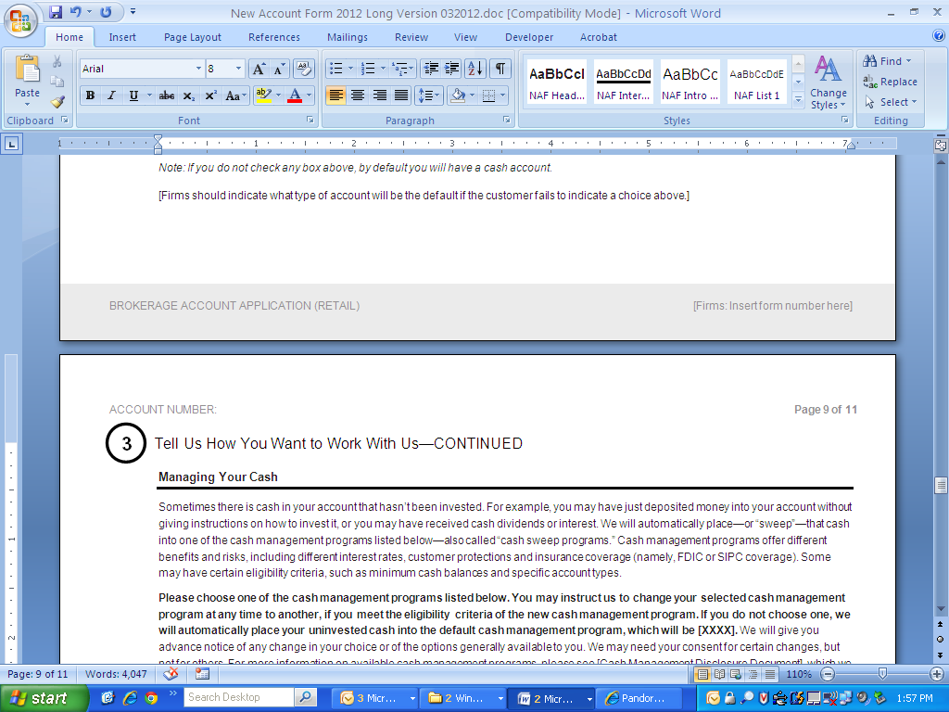
Managing Your Cash
Sometimes there is cash in your account that hasn’t been invested. For example, you may have just deposited money into your account without giving instructions on how to invest it, or you may have received cash dividends or interest. We will automatically place—or “sweep”—that cash into one of the cash management programs listed below—also called “cash sweep programs.” Cash management programs offer different benefits and risks, including different interest rates, customer protections and insurance coverage (namely, FDIC or SIPC coverage). Some may have certain eligibility criteria, such as minimum cash balances and specific account types.
Please choose one of the cash management programs listed below. You may instruct us to change your selected cash management program at any time to another, if you meet the eligibility criteria of the new cash management program. If you do not choose one, we will automatically place your uninvested cash into the default cash management program, which will be [XXXX]. We will give you advance notice of any change in your choice or of the options generally available to you. We may need your consent for certain changes, but not for others. For more information on available cash management programs, please see [Cash Management Disclosure Document], which we will provide to you.
Sales proceeds (check one): | Dividends/interest (check one):
□ Mail check to the address of record  □ Send directly to your bank account. Please provide bank name and account number:  □ Sweep into Money-Market Fund  Securities Investor Protection Corporation (SIPC³) Protected  □ Sweep into Money-Market Deposit Account  Federal Deposit Insurance Corporation (FDIC⁴) Insured  □ Other: | □ Mail check to the address of record  □ Send directly to your bank account. Please provide bank name and account number:  □ Sweep into same investment as indicated at left  □ Reinvest in the same security
[Firms should customize this section consistent with the cash sweep options they offer.]
³ SIPC protects customers of brokerage firms that are closed due to bankruptcy or other financial difficulty. Each customer may be protected up to $500,000, including up to $250,000 in cash held in the account. SIPC will cover any missing customer securities when the brokerage fails, whether the securities are missing due to conversion, theft, unauthorized trading or other reasons. SIPC does not protect against ordinary market loss. Not every investment is protected by SIPC and some customers may be ineligible to have their claims satisfied with SIPC funds. More information can be found at www.sipc.org or by calling 1-202-371-8300.
⁴ Under FDIC coverage, if a bank or savings association fails, each depositor generally is insured for up to $250,000 for non-retirement accounts, and up to $250,000 for IRAs and certain other retirement accounts. The FDIC coverage does not insure securities or mutual funds. More information can be found at www.fdic.gov or by contacting the FDIC at 1-877-ASK-FDIC.
Communication Choices
Communication Options
Unless you choose otherwise, we will use postal mail to send you any communications. As an alternative, you may choose to be notified by email when certain communications are available for you to access online. If you wish to be notified by email instead of receiving communications by postal mail, please select one of the options below:
- All communications – I wish to be notified by email about the online availability of any communications, including trade confirmations, prospectuses, account statements, proxy materials, tax-related documents, and marketing and sales documents.
- All communications except trade confirmations, account statements, and tax-related documents – I wish to be notified by email about the online availability of all communications except trade confirmations, account statements, and tax-related documents, which I still wish to receive by postal mail.
- All communications except tax-related documents – I wish to be notified by email about the online availability of all communications except tax-related documents, which I still wish to receive by postal mail.
If you choose email for any communications, please tell us the email address we should use:
A copy of [Firm’s] privacy policy will be provided to you along with this Application. [Firms can tailor this language to reflect how they will deliver their privacy policy to the customer.]
Postal Mail Options (if you requested postal delivery in the previous section)
By checking the boxes below, you request that all communications for the applicants listed on this Application be delivered to the following single postal mailing address:
□ Primary Applicant’s Mailing Address
□ Co-Applicant’s Mailing Address
□ Other. Please specify:

Duplicate Copies (optional)
Please send duplicate copies of the following documents to the person listed below:
□ All Communications □ Trade Confirmations, Account Statements, and Tax-Related Documents □ Tax-Related Documents Only
□Mr. □Mrs. □Ms. □Dr. Suffix □Sr. □Jr.
First Name Middle Name Last Name
Address Apt/Suite No.
City State ZIP Code Country
Relationship to Primary Applicant/Co-Applicant:

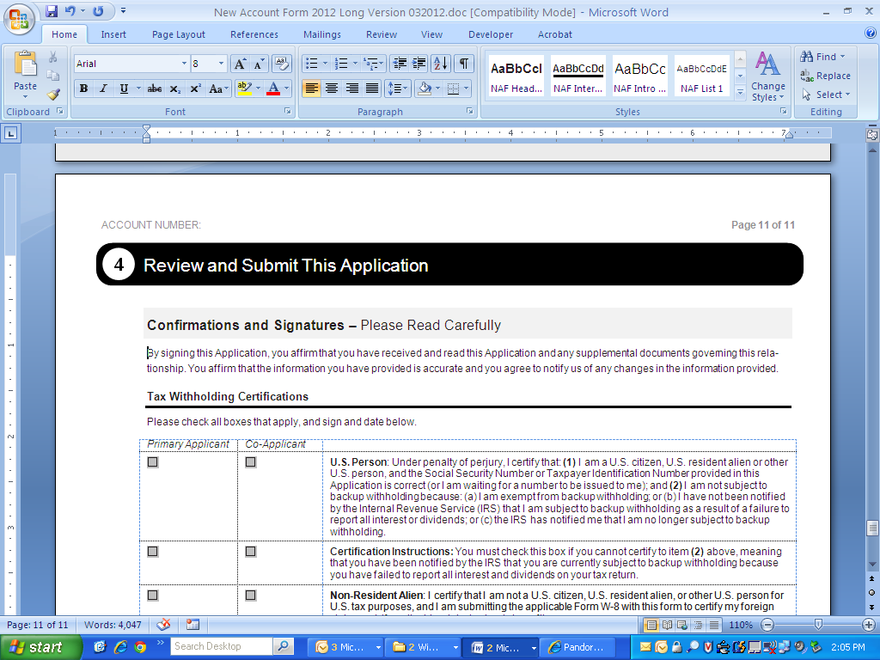
By signing this Application, you affirm that you have received and read this Application and any supplemental documents governing this rela- tionship. You affirm that the information you have provided is accurate and you agree to notify us of any changes in the information provided.
Tax Withholding Certifications
Please check all boxes that apply, and sign and date below.
Primary Applicant | Co-Applicant
□ | □ | U.S. Person: Under penalty of perjury, I certify that: (1) I am a U.S. citizen, U.S. resident alien, or other U.S. person, and the Social Security Number or Taxpayer Identification Number provided in this Application is correct (or I am waiting for a number to be issued to me); and (2) I am not subject to backup withholding because: (a) I am exempt from backup withholding; or (b) I have not been notified by the Internal Revenue Service (IRS) that I am subject to backup withholding as a result of failure to report all interest or dividends; or (c) the IRS has notified me that I am no longer subject to backup withholding.
□ | □ | Certification Instructions: You must check this box if you cannot certify to item (2) above, meaning that you have been notified by the IRS that you are currently subject to backup withholding because you have failed to report all interest and dividends on your tax return.
□ | □ | Non-Resident Alien: I certify that I am not a U.S. citizen, U.S. resident alien, or other U.S. person for U.S. tax purposes, and I am submitting the applicable Form W-8 with this form to certify my foreign status and, if applicable, claim tax treaty benefits.
[Note: If the firm uses a Predispute Arbitration clause, it must comply with applicable FINRA disclosure requirements and restrictions on provisions that limit rights and remedies.]
The Internal Revenue Service does not require your consent to any provision of this document other than the certifications required to avoid backup withholding.
Signatures
Primary Applicant Name (please print)
Primary Applicant Signature Date
Co-Applicant Name (please print)
Co-Applicant Signature Date
[Firms should insert their principal and other required signature blocks here. Firms may also include or attach any additional disclosures such as privacy policies, business continuity plans, revenue sharing disclosures, etc.]
Please mail your completed Application to the address listed below, or fax it to [1-999-000-9999].
Brokerage ABZ, 153 Securities Way, Suite 1001, Richmond, VA 00150

